Wordpress usage
Wordprees is currently considered one of the best options to create a web page, since it is open source and you don't need any knowledge of web programming.

Actually Wordpress is the most popular website-making platform, powering nearly half (43.4%) of all websites – an increase of more than 25% since 2013.

Various factors contribute to WordPress’s popularity, including its user-friendly interface, extensive customization options, strong community support, and scalability for different website types.

WordPress Dominates the CMS Market With a 62.8% Share
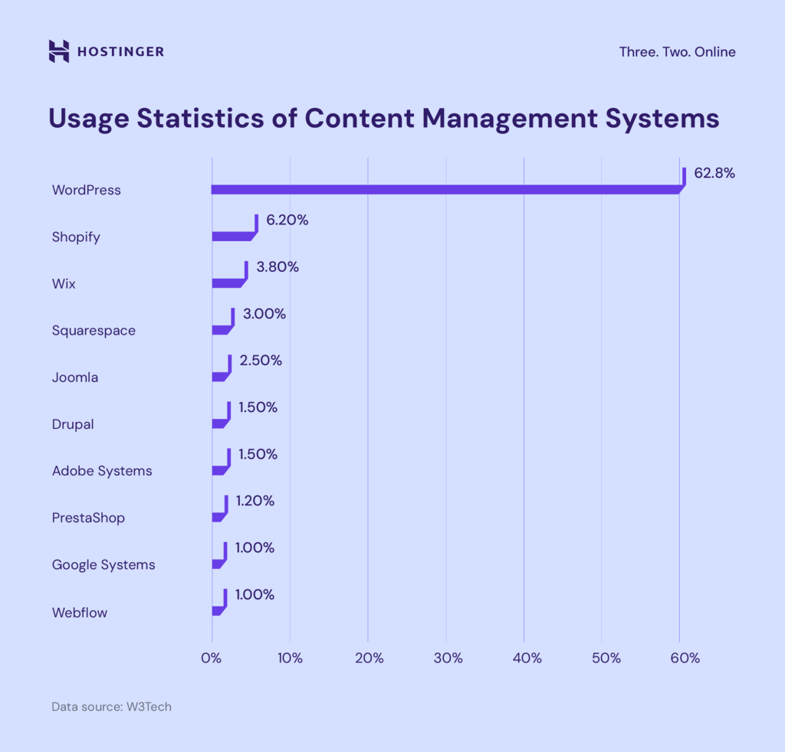

Over the past decades, WordPress has consistently been the fastest-growing CMS.

Today, it has a global CMS market share of 62.8%, which is 10 times higher than Shopify, its closest competitor (6.2%). Other popular site-building tools include Wix (3.8%), Squarespace (3%), and Joomla (2.5%).

